Class8

Rimma Levina

2/5/2020

## K-means clustering

Lets try the kmeans() function in R to cluster some made up example data

tmp <- c(rnorm(30,-3), rnorm(30,3)) #this makes up data, 1st = 30 points centered around -3, 2nd = 30 points centered around +3 --> makes a vector that has 60 points  
  
x <- cbind(x=tmp, y=rev(tmp)) # cbind() binds together vectors, you are also setting the axes, where x is the first vector and y is the reverse (rev()) of the tmp vector, then you plot and see you have 2 groups that are clearly separate/clustered  
   
plot(x)

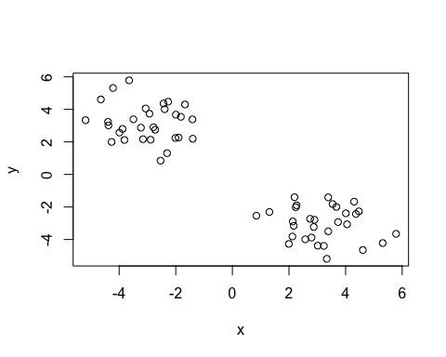 Use the kmeans() function setting k to 2 and nstart=20 Inspect/print the results Q. How many points are in each cluster? Q. What ‘component’ of your result object details - cluster size?  
- cluster assignment/membership?  
- cluster center?

Plot x colored by the kmeans cluster assignment and add cluster centers as blue points

km <- kmeans(x = x, centers = 2, nstart = 20)   
km

## K-means clustering with 2 clusters of sizes 30, 30  
##   
## Cluster means:  
## x y  
## 1 -3.028551 3.179342  
## 2 3.179342 -3.028551  
##   
## Clustering vector:  
## [1] 1 1 1 1 1 1 1 1 1 1 1 1 1 1 1 1 1 1 1 1 1 1 1 1 1 1 1 1 1 1 2 2 2 2 2 2 2 2  
## [39] 2 2 2 2 2 2 2 2 2 2 2 2 2 2 2 2 2 2 2 2 2 2  
##   
## Within cluster sum of squares by cluster:  
## [1] 68.17138 68.17138  
## (between_SS / total_SS = 89.5 %)  
##   
## Available components:  
##   
## [1] "cluster" "centers" "totss" "withinss" "tot.withinss"  
## [6] "betweenss" "size" "iter" "ifault"

attributes(km) is a function to get the details of your data

km$size

## [1] 30 30

km$cluster

## [1] 1 1 1 1 1 1 1 1 1 1 1 1 1 1 1 1 1 1 1 1 1 1 1 1 1 1 1 1 1 1 2 2 2 2 2 2 2 2  
## [39] 2 2 2 2 2 2 2 2 2 2 2 2 2 2 2 2 2 2 2 2 2 2

table(km$cluster)

##   
## 1 2   
## 30 30

Now plot colored by the kmeans cluster assignment, and add cluster centers as blue points so find CENTERS, then add to exsiting plot

plot(x, col=km$cluster)  
points(km$centers, col="blue", pch=16, cex=3)

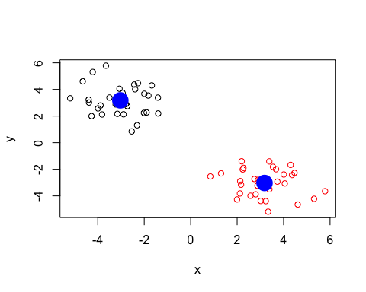

## Hierarchical clustering in R

The hclust() function is the main hierarchical clustering method in R and it MUST BE PASSED THROUGH A MATRIX AS INPUT, not your raw data!!!!

hc <- hclust( dist(x)) # this hopefully reveals patterns in your data  
plot(hc)

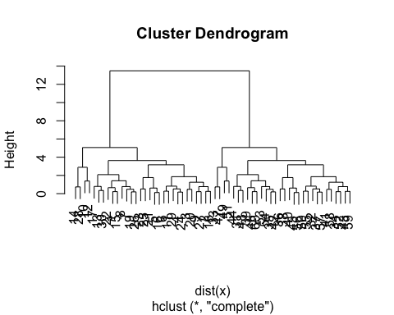

plot(hc)  
abline(h=6, col="red", lty= 2)# makes a line above where you want to cut off the data  
abline(h=3.5, col="blue", lty= 2)

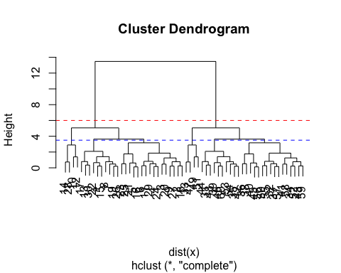

cutree(hc, h=6) # lists all the points below that line you cut

## [1] 1 1 1 1 1 1 1 1 1 1 1 1 1 1 1 1 1 1 1 1 1 1 1 1 1 1 1 1 1 1 2 2 2 2 2 2 2 2  
## [39] 2 2 2 2 2 2 2 2 2 2 2 2 2 2 2 2 2 2 2 2 2 2

You can call cutree with k for the number of groups you want, or with h for height

cutree(hc, k=6) # having a lower cut off you see now you have 6 clusters

## [1] 1 2 2 2 2 2 1 1 2 3 2 3 1 3 1 2 1 2 1 2 2 1 2 2 2 1 2 3 2 1 4 5 6 5 4 5 5 5  
## [39] 4 5 5 4 5 4 5 4 6 4 6 5 6 5 4 4 5 5 5 5 5 4

## Linkage

# Step 1. Generate some example data for clustering  
x <- rbind(  
 matrix(rnorm(100, mean=0, sd=0.3), ncol = 2), # c1  
 matrix(rnorm(100, mean=1, sd=0.3), ncol = 2), # c2  
 matrix(c(rnorm(50, mean=1, sd=0.3), # c3  
 rnorm(50, mean=0, sd=0.3)), ncol = 2))  
colnames(x) <- c("x", "y")  
# Step 2. Plot the data without clustering  
plot(x)

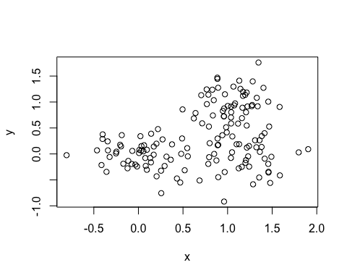

# Step 3. Generate colors for known clusters  
# (just so we can compare to hclust results)  
col <- as.factor( rep(c("c1","c2","c3"), each=50) )  
plot(x, col=col)

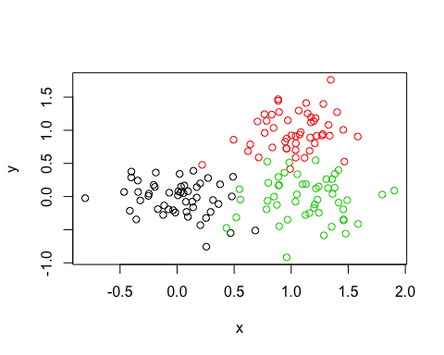

Q. Use the dist() for distance matrix, hclust(), plot() and cutree() functions to return 2 and 3 clusters Q. How does this compare to your known ‘col’ groups?

hc <- hclust(dist(x))  
plot(hc)

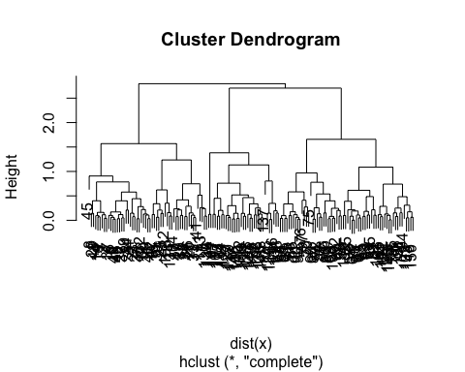

grps2 <- cutree(hc, k=2)  
grps3 <- cutree(hc, k=3) #these are membership vectors

table(grps2)

## grps2  
## 1 2   
## 55 95

table(grps3)

## grps3  
## 1 2 3   
## 55 62 33

plot(x, col=grps3) # color by the group distribution

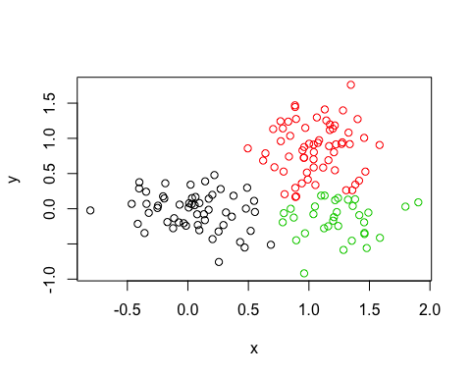

table(grps3, col) #this is a cross table, using col from line 102, saying for group 1 all 42 points come from cluster 1, for group 2 most points come from cluster 3, for group 3 most points come from cluster 2 - so only group 1 is mostly right

## col  
## grps3 c1 c2 c3  
## 1 50 1 4  
## 2 0 49 13  
## 3 0 0 33

# Principle Component Analysis (PCA)

The main function in R for PCA is called prcomp(). Here we will use PCA to examine the funny food that folks eat in the UK and N. Ireland.

Import the CSV file first:

x <- read.csv("UK_foods.csv", row.names = 1)  
x

## England Wales Scotland N.Ireland  
## Cheese 105 103 103 66  
## Carcass_meat 245 227 242 267  
## Other_meat 685 803 750 586  
## Fish 147 160 122 93  
## Fats_and_oils 193 235 184 209  
## Sugars 156 175 147 139  
## Fresh_potatoes 720 874 566 1033  
## Fresh_Veg 253 265 171 143  
## Other_Veg 488 570 418 355  
## Processed_potatoes 198 203 220 187  
## Processed_Veg 360 365 337 334  
## Fresh_fruit 1102 1137 957 674  
## Cereals 1472 1582 1462 1494  
## Beverages 57 73 53 47  
## Soft_drinks 1374 1256 1572 1506  
## Alcoholic_drinks 375 475 458 135  
## Confectionery 54 64 62 41

# Notice that X is the lable for the first column, but you want that to be the row names. You can fix that in the import function, with row.names=1

barplot(as.matrix(x), beside=T, col=rainbow(nrow(x)))

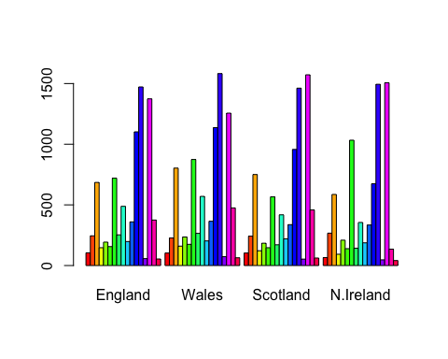

pairs(x, col=rainbow(10), pch=16) #Makes a matrix of scatterplots

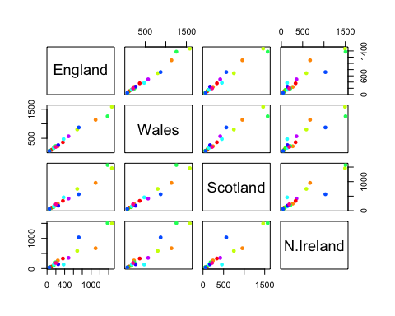

#PCA to the rescue!

pca <-prcomp(t(x)) #taking the transpose of x makes the rows the column names

summary(pca)

## Importance of components:  
## PC1 PC2 PC3 PC4  
## Standard deviation 324.1502 212.7478 73.87622 4.189e-14  
## Proportion of Variance 0.6744 0.2905 0.03503 0.000e+00  
## Cumulative Proportion 0.6744 0.9650 1.00000 1.000e+00

attributes(pca)

## $names  
## [1] "sdev" "rotation" "center" "scale" "x"   
##   
## $class  
## [1] "prcomp"

plot( pca$x[,1], pca$x[,2] )  
text(pca$x[,1], pca$x[,2], colnames(x), col=c("black", "red", "blue", "darkgreen"))

